Kindergarten

News

Mr. Bouckaert’s Classroom Newsletter

### Fairview Elementary

Jennings School District

9/8/2015

Volume 1, Issue 2

# FALLing into September

banner with apples and crayons

to help you stay up to date on our class “amazing words” that change weekly and our reading concept focus. For example this current week we are working on retelling stories in the order in which they happen, or sequencing.

One month down already! This month has gone quickly by and we are knee deep in our studies through kindergarten. After morning work we dive into phonics time which is where we learn to identify and say sounds that letters make in different words. We are really focusing on beginning and ending sounds. This is a corner stone to reading. Continue to use the PAWS newsletters that are sent home weekly to help further your students learning at home. We also have a few students who are continuing to learn to recognize letters so while that suggestion may not be with the PAWS newsletter, continue working with your student if they struggle with letter identification.

After phonics time we practice writing some letters and then move into math. In math we are working on identifying, labeling and representing numbers. We will start with numbers under 5 and then move to numbers under 10.

The reading newsletters that come home every Monday will also continue

# Snack reminder

I sent home a snack request form the week of parent teacher conferences asking for families to assist with snacks. We will rotate months so everyone can help. I did August, I am asking girls to do September and then boys to do October. After October we will continue to rotation starting with me for November and so on. If you could bring enough snack for 22 students for 3 days of snack it would really help us to provide snack daily. I know some of you have already brought but in case anyone has not seen the note I thought I’d send out a reminder.

Please continue to encourage your child to respect each and every person in school and to give everything their best until the end of the day. In our class, if they are having an issue with someone I tell them to ask for a break and then I allow them to sit in the class to “cool off” quietly with their head down if they need. Then when we are able to talk about the problem, we collect all involved and talk it out. Tensions get high when breaks are not asked for and it’s harder for everyone to calm down. Sometimes everyone just needs a few moments to collect themselves and think about their actions.

# Respect

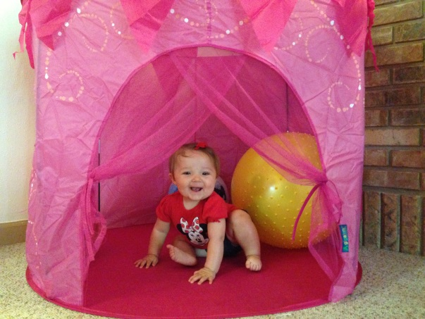

There

*My littlest one didn’t get to make her depute on my first newsletter so had to include her this time!*

# Contact info

E-mail: [bouckaertj@jenningsk12.org](mailto:bouckaertj@jenningsk12.org)

#### Thank You for all you do!

We’ve had a few students fill up their sticker chart for a prize out of the treasure box! When your students comes home saying they got stickers on their sticker chart today, CELEBRATE! That means they were caught doing something good.

As a school we also give out BRAVE bucks throughout the day. These are to stay at school because during a certain day of the month student are allowed to visit the “store” and spend their “bucks” for something of their choosing.

# Sticker chart and BRAVE bucks

* Respectful
* Responsible
* Safe

These three rules have been adopted by our entire school as the expectations of each student while they are here.

## Fairview students are…

Reminder that your students homework folder needs to come back to school daily with their behavior chart. Homework will always need to be returned to school, notes and graded work can stay at home unless I have put a note for you to sign and return. I have been asked if your students folder is damaged do they have to have a green folder to replace it. The answer is no they do not. As long as they have a folder for homework and notes they are good to go.

Other school wide resources being used this year are the “high five.”

This is an attention getter for students when the teacher needs to focus them on him or her. The teacher will say “I need a high five.” And the class will respond by raising their hand, stopping what they are doing, listening, keeping their hands still, voices off, and eyes on the teacher.

Mr. Bouckaert’s Classroom Newsletter Page 2

## High five

# Homework folders

school supplies