Kindergarten

News

### Fairview Elementary

Jennings School District

10/8/2015

Volume 1, Issue 3

# What’s been going on

banner with apples and crayons

What’s hopping’ in Mr. BOOckaert’s room



Our new amazing words and text focus for the week as well as ideas to try at home. I am sending home vocab readers every Friday to help build each students reading library at home with our word wall words. These are books your student should practice reading to you.

The student have been doing really well with identifying beginning and ending sounds in two and three letter words and we will continue to work on letter sounds this month. Continue reading the PAWS newsletters that come home weekly for ideas of how to help at home. If you ever need another copy please contact me or look at our parent news bulletin board outside the classroom.

In mathematics we have just finished our second unit which focused on writing, representing, and identifying numbers from 6-10. As a class we are moving on to comparing and contrasting groups of objects to see which has more and which has fewer. We will also continue to work on writing our numbers correctly with numbers under 10 and a few of us will progress to numbers above 10. We are still having some difficulty writing our numbers neatly but practice makes perfect!

Our language arts focus changes weekly so the easiest way to keep up to date on that is read the Monday newsletter that comes home showing

# Snack reminder

I am late sending a reminder home, so my apologies, but this month is the boys’ month to provide snack. Thank you to those who have already brought in snack. Ideas are crackers, gold fish, pop-corn, oatmeal crème pies, etc. Just nothing with peanuts please. Thanks again!

# Respect

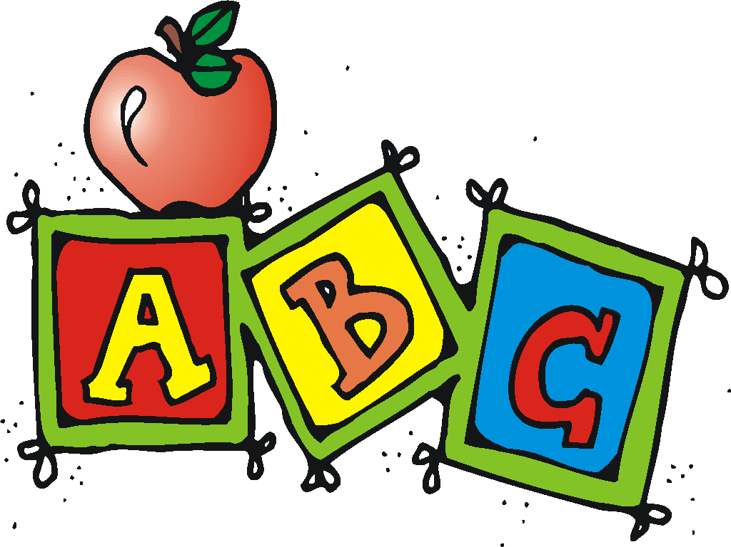

\We have been talking a lot in class about how we treat everyone with respect and in return we expect respect from others. One area we struggle with this in is when a friend is upset or when the student themselves is upset. Because of this we have been working on how to deal with being angry or sad.

We talk very often about how being angry or sad is okay but we have to make sure we aren’t disrespectful to someone who doesn’t deserve to be disrespected. We talk about ways to calm ourselves down and how to politely tell someone “I don’t want to talk right now.”

This can be difficult for some because sometimes they just want to be a good friend and try to comfort someone who is upset, but that person may not want to be comforted and in turn gets angry. I say this just to encourage you to have conversations at home. This can be a hard thing to learn because situations are sometimes hard to judge for 5 and 6 years olds but we are trying to learn some skills to help.

There

*Keeping working on letter identification and sounds!*

E-mail: [bouckaertj@jenningsk12.org](mailto:bouckaertj@jenningsk12.org)

# Contact info

#### Thank You for all you do!

I have started a blog on our classroom webpage as a way for you to keep updated about things to go home or things that are happening in the classroom. This will update as frequently as I have something to post about. If you want to check out the webpage here is a link you can plug into your computer or phone.

bouckaert.weebly.com

# Web site blog

The Fall party is on October 30th starting at 2:00. I will be providing a special snack, special craft and show for us to watch that day. If you are available and could volunteer your time to come help I would greatly appreciate it! Please contact me. I need two volunteers and will simply take the first two who approach me. Don’t worry if you don’t get to me first, there are plenty more parties this year ☺

## Graded work

Graded work comes home with the HW folders. A smiley face means they got a 3 which means they scored proficient. A 2 means they are advancing to proficient and a 1 means they struggled with the concept and we will continue working with the concept in class and through HW.

Reminder that your students homework folder needs to come back to school daily with their behavior chart. Homework will always need to be returned to school, notes and graded work can stay at home unless I have put a note for you to sign and return. I have been asked if your student’s folder is damaged do they have to have a green folder to replace it. The answer is no they do not. As long as they have a folder for homework and notes they are good to go.

# Fall Party

Our school wide rules in the hallway is to use W.A.L.K.S. which stands for

Walk

Always stay to the right

Look straight ahead

KHFOOTY (Keep hands, feet and other

objects to yourself)

Shhhhhhh

Our class has been working very hard on this ☺

Mr. Bouckaert’s Classroom Newsletter Page 2

## W.A.L.K.S.

# Homework folders

school supplies